Northumbrian Road
Cramlington
Northumberland
NE23 6DB

Tel: (01670)716343 Extn: 1
Email: office@ss-peterandpauls.co.uk

Executive Headteacher: Mrs Charlotte Chapman

Ss Peter & Paul’s Catholic Primary School

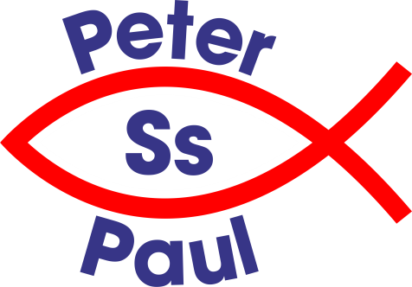

Dear Parents/Carers
School Club Booking and Payment
Booking and payment for the Before and After-School Club must be done ahead of time on a weekly basis. For example, if you wish to book your child/children into the School Club for any day of the week commencing from Monday you must go on your child’s iPayimpact account, choose the type and number of sessions you require for that full week and pay upfront by 12 noon on the Friday of the previous week. You will then need to do this for every week going forward.
After you have paid for the sessions on iPayimpact please send a booking email to schoolclub@ss-peterandpauls.co.uk stating which days and if it is Before-School or After-School that is required.
If you are paying by childcare voucher you will not use the iPayimpact system but instead send a booking email to the School Club. Then provide Mrs Marshall the name of the provider, date of payment, amount of payment and reference number so that the payments can be matched on our accounts.
Bookings will not be taken through the school office either by phone or school email.
Except in the case of an emergency if a place is not pre-booked and pre-paid an extra fee of £4.50 will be charged. Please note a cancellation fee of £3.00 will be charged if a booked session is not cancelled within 24 hours. If you have booked and paid for your child/children and they are absent from school on the day the amount will be carried forward as a credit.
If you have any query about how to book and pay please contact the school office.
Kind regards
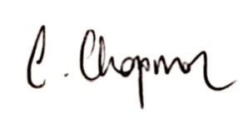
Mrs C Chapman
Executive Headteacher

